PALM DM TUTORIAL 1
DESIGN YOUR FIRST WARRIOR
- Start the program, Hit Start, then Hit Design.

Your Screen should look something like this. | 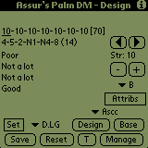
- Parts of the design screen.
- Statistics Line  - Skills if mode from above stats (Ordered according to settings, alphabetical or RSI order)  - Change statistic (noted by underline)  - Increase or Decrease Stat buttons  - Style Selection (Ordered by settings)  - Show Attributes or Skill messages expected on sheet. Note that Damage is the middle possible value, not the most likely value.  - Skill chart being used  - Reset stats to the base values (see the Set button)  - Clear the current warrior and set and reset to all 10’s.  - Save this warrior  - Set the current skills as the base warrior (normally the original 70 point overview) which will be saved with the warrior and also used for the Base Warrior button.  - Expected Messages on the Overview (Skills or Stats). Skills are always listed in RSI order (order they will appear on the overview.  - Exit the Design Screen and go to the Manager Screen. Designed warrior is gone.  - Exit the Design Screen and go to the Team Screen. Designed warrior is gone. | 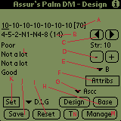
- Select the Skill Chart you wish you use, if different from the default. (G)
- Using the Left/Right and +/- buttons, set the attributes to the rollup you’ve received from RSI (C & D)
- Press the Set Button (K). This saves the original stats (will be saved with the warrior and also easy to reset the numbers back to these values during the design process)
- Using the Left/Right buttons, +/- buttons, and style button to explore possibilities for the rollup you’ve received. The total of the stats is listed in the brackets so you’ll know if you’ve added all your points or not. When finished, your screen should look something like this:
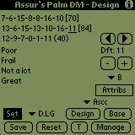
- Press the Save Button. This brings up the following screen. You can now enter the Name of the warrior, the arena, and the team (If you’ve configured teams). All of these can be changed later. Press Save or Cancel after entering the information.
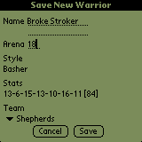
- When RSI sends back the rolled warrior, you need to input the overview information. You will now go to the Manager Page, highlight the new warrior, and press the OView Button. This brings up 3 consecutive screens to input the warrior as he actually rolled and allow the program to calculate your possible bonuses and record your progress as he advances through the ranks. Please note that this should be recorded BEFORE trains that you may have received on your first turn, if you fought before the turn. Ex. If Broke Stroker fought turn 1, increased his Strength and got a damage bump to Great damage, you would record his initial damage as Good, not great.
  - Screen 1: ID, Handedness, Wit Statements, Activity.
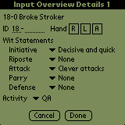
  - Screen 2: Physical Attributes
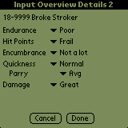
  - Screen 3: Ratings on the overview
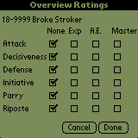
- Congratulations. You’ve now entered your first new warrior. You can now enter more warriors or start to manage your warrior’s career.

